NEWTECH QUALITY MANUAL | JAN 9  2015
Possesses a Quality Control System that operates with a fully automatic control mechanism, and that begins from the stage of procuring raw materials to the final stage of pipe manufacture.  It is presented to the consumer with complete assurance with impermeability, external load resistance, and environmental protection factors reinforced a lot more at each stage.  Without exception, each product that has completed the manufacture process meticulously undergoes all the tests stated in the international standards |  | QA

1. SCOPE

The NEWTECH-QMS defines the policies, objectives, responsibilities, and infrastructure of NEWTECH.

This includes:

- Customer interaction
- Resource management
- Product realization
- Monitor, measure & analysis for continual improvement

2.0 NORMATIVE REFERENCE

ISO 9001: 2008, Quality Management System – Requirements

ISO 9000: 2000, Quality Management System - Fundamentals and vocabulary

3.0 TERMS & DEFINITIONS

The following abbreviations are used throughout this Quality Assurance Manual:

ACAR : Internal Quality Audit Corrective Action Request
APC : Angled Physical Contact
CAR : Corrective and Preventive Action Request
CEO : Chief Executive Officer
CMS : Cable Manufacturing Section
FC : Ferrule Connector
HOD : Head of Department
IEC : International Electrotechnical Commission
ISO : International Organization for Standardization
ITU : International Telecommunication Union
NEWTECH : New Tech pipes
MMD : Materials Management Department
PC : Physical Contact
QMD : Quality Management Department
QMR : Quality Management Representative
QMS : Quality Management System
R & D : Research & Development
SC : Square Connector
SPC : Super Physical Contact
ST : Straight Connector
ts : Telecom Solutions
UPC : Ultra Physical Contact
pvc : Polyvinyl Chloride
HDPE : High-density polyethylene

4. QUALITY MANAGEMENT SYSTEM

4.1 General

The NEWTECH model for the quality management system is derived from ISO 9001 and is supplemented by customer specific requirements. A specific quality system model, ISO 9001 provides the framework, for areas to be documented, implemented, maintained and improved with appropriate feedback from inspection, audits, and customers, to assess system effectiveness.

NEWTECH manual covers all of these processes and sub-processes, which are detailed in NEWTECH Quality Operating Procedures.

The sequence and interaction of the processes within the QMS are described in the Figure 1.

NEWTECH QMS maintains control overall processes that affect product conformance to requirements, regardless of whether the process is completed internally or by an external supplier.

Figure 1 : Process / Customer Interaction

4.2 Documentation

NEWTECH Quality Management System is documented and based on the concept, principles guidelines and requirements of ISO 9001:2008. The Quality Management System consists of following five levels of documentation;

- Quality Policy & Quality Objectives
- Quality Management System Manual
- Quality Operating Procedure Manual
- Work Instruction
- Forms & Records

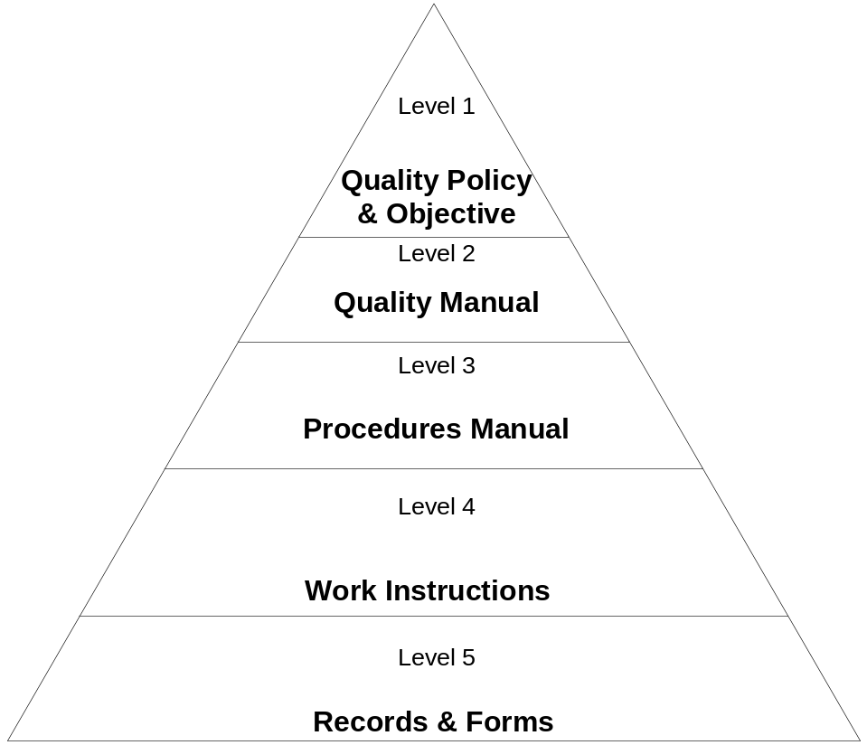

Figure 2 : QMS Documentation Structure
Level 1: Quality Policy & Quality Objective

Quality policy & objectives are described in detail in section 5.3 & 5.4.1 of this manual.

Level 2: Quality Manual

QA/QM/001 is the whole document which describes the complete framework of NEWTECH QMS.

Level 3: Quality Operating Procedures

All the requirements of ISO 9001:2008 and processes of QMS are clearly defined in the Quality system procedures, which addresses the process execution, sequence and interaction of each process to other processes.

See the List of all Quality Operating Procedure in Annexure "A"

Level 4: Work instructions

Work Instructions are the fourth level document in NEWTECH QMS. The department head prepares and maintain all work instructions required for the execution and/or interaction of process with any other process of QMS.

Level 5: Records

Records required by the ISO 9001:2008 standard as well as by the NEWTECH QMS have been identified in the respective QMS procedures and work instructions. Records are generated and maintained by the Head of Department / process owner in order to ensure the effectiveness and conformity of operation of QMS.

4.3 Control of Documents

A documented procedure has been established in NEWTECH. Control of Document is extended to all Quality Manual, Quality Operating Procedures, Work Instructions, Forms and other supporting documents which include manuals, testing data, proprietary documents related to the operation of QMS.

4.4 Control of Quality Records

The quality records include product specifications, drawings and operating features as well as reports and related results pertaining to inspection, testing, survey, audit, review, calibration, quality costs and order specific documents relevant to quality. A documented procedure is established in this regard.

5.0 Management Responsibility

NEWTECH top management consists of;

- Chief Executive Officer NEWTECH
- Department Head Research & Development
- Department Head Production
- Department Head Quality Management
- Department Head Materials Procurement
- Department Head Telecom Solutions
- Department Head Marketing
- Department Head Outside Plant

5.1 Management Commitment

NEWTECH Top Management;

- Ensures that the customer requirements and deliverables at all stages of Design, Planning, Production, Testing and after sales activities as stipulated in NEWTECH QMS.

- Strives to maintain an effective level of conformance towards the implementation of QMS during all stages of management activities.

- Has established the quality policy, which is appropriate to the purpose, ideology and corporate principles of the company.

- Conducts management reviews to ensure the continuing suitability, adequacy and effectiveness and to assess the opportunity for improvement and the need for changes to the QMS

5.2 Customer Focus

NEWTECH top management ensures that customer requirements are determined and are met with the aim of enhancing Customer satisfaction by;

- Customer Surveys
- Customer Complaint
- Customer Feedback
Management Reviews the results of internal / external audits, customer needs assessment, and receives customer feedback data on a regular basis as a function of Management Review. (see Section 5.6 for detail).

5.3 Quality Policy

- NEWTECH Pipes. designs, develops, manufactures high quality Poly(Vinyl Chloride) (PVC) Plastic Drain, Waste, and High density polyethylene (HDPE )Conduit Using an ASTM International Standard to Design and Build Your Network
- accessories and provides telecom solutions to meet customer’s expectation.

- The adoption of ISO 9001 Quality Management System delivers consistent, systematic and error free quality operating procedure ensuring all aspects of continual improvement.

- To create a challenging and rewarding work environment with a proactive management that encourages our employees to work with commitment and dedication.

- Higher productivity, innovations and growth in market share are the company wide objectives, which are measurable and target at all functional levels and their results are monitored for continual improvement.

Muhammad Kazim Abbass
Chief Executive Officer

5.4 Planning

    - Quality Objectives

- In order to implement the QMS, All departments within the QMS shall set the departmental objectives at all functional levels. These quality objectives are reviewed and approved every year in MRC meeting.

    - Quality Management System Planning:

Quality planning includes identification and determination of QMS processes; priorities for continual improvement; and resources needed to achieve quality objectives and to maintain and improve the QMS. Quality plans are periodically reviewed and updated to maintain the integrity of QMS during organizational and other changes as and when required bases.

Planning of product realization, verification, and validation processes are addressed in Section 7.0 of this manual.

Responsibility, authority and communication

5.5.1 Responsibility and Authority

The responsibilities and authorities are identified with functions and their interrelations within NEWTECH QMS as per Figure 1. NEWTECH has defined and communicated these responsibilities in the form of job descriptions maintained by management and available with respective areas.

All levels of personnel have the authority to inform nonconforming processes and initiate, recommend, or provide corrective / preventive solutions through designated channels.

The Quality Management Representative shall have the necessary authority and organizational freedom to resolve matters pertaining to quality.

5.5.2 Management Representative

The Chief Executive Officer has appointed the Management Representative who, irrespective of other responsibilities, has the responsibility and authority to;

      - Establish and maintain NEWTECH QMS.
      - Report the performance and needed improvements to the top management regarding NEWTECH QMS.
      - Promote awareness of the policies, objectives, progress on quality management system performance and customer satisfaction and changes in the quality management system.

5.5.3 Internal Communication

NEWTECH management has established the processes for training and regular management reviews. Supporting ways of communications are voice message announcements, newsletters, daily interactions, memos, circular and group meetings.

5.6 Management Review

    - General

The top management team review the Quality Management System. This review identifies trends and adjusts policy and business plans, as necessary to meet the established goals for customers, suppliers, and internal activity. The reviews shall also address, as appropriate, suitability of the Quality Policy, quality objectives and Quality Management System; changing business needs, customer satisfaction, operational and performance results, continual improvement, assessment of resources, the results of quality audits, and corrective and preventive action activities. Records of quality system reviews shall be maintained.

The detail procedure (QOP/56/05) is established.

5.6.2 Review Input

The input to management review shall include information on:

- Goal Setting(Quality Policy & Quality Objectives)
- Audit results
- Process performance and product conformity(Status of Non-conformances)
- Supplier performance
- Marketing Issues
- Status of preventive and corrective actions
- Customer Complaint Analysis & Customers Feedback
- Follow up actions from previous management reviews
- Changes that could affect the quality management system
- Recommendations for improvement
- Any other point from the management

5.6.3 Review Output

The outputs from the management review will include actions related to the:

- improvement of the quality management system and its processes;
- improvement of product related to customer requirements;
- resource needs.

Results of management reviews are recorded and maintained according to Procedures.

RESOURCE MANAGEMENT

6.1 Provision of Resources

It is the responsibility of Top Management of NEWTECH to ensure that the resources essential to achieve of the organization’s objectives, including:

- implementing,
- maintaining,
- improving the quality management system,
- and enhancing customer satisfaction,

are identified during the planning processes.

Resource requirements are usually planned during the budgeting process and adjusted accordingly.

Management shall review the adequacy of resources and adjustments shall be made based on identified business needs.

6.2 Human Resources

6.2.1 General

NEWTECH have defined the induction, promotion and training processes

Provision of adequate trained personnel to perform the required tasks is addressed in all departments. Personnel performing work affecting quality are competent and adjudicated on the basis of:

- appropriate education,
- training,
- skills and
- experience

6.2.2 Competence, awareness and training

Competence:

All NEWTECH personnel involved with product quality maintain a competence level as stipulated by the Department Head for carrying out the required task.

Training:

Concerned Department Heads identify the appropriate minimum levels of training or experience required for assignment to the positions under their direction, ensure all personnel receive required training, and maintain appropriate on-the-job training records, as and when required.

Human resource department is to maintain personnel file for all personnel of NEWTECH. These files will include, at a minimum, a job description, educational information, work experience and training certificates.

The QMS management representative is responsible for ensuring personnel are provided adequate training in the implementation of the QMS. The detail procedure (QOP/62/03) is established.

6.3 Infrastructure

NEWTECH Management provides and maintains the infrastructure necessary to ensure that product conforms to the established requirements.

6.4 Work Environment

Concerned Department Head are responsible for the facilities, including workstations and associated equipment, are maintained in a state of order, cleanliness, and repaired appropriate to the product(s) manufactured or to the service being provided. All work areas must comply with established safety and regulatory standards.

The established requirements, including addressing of product safety and means to minimize potential risks to employees, NEWTECH especially defines these requirements in design, development, and manufacturing/services process activities.

7. Product Realization

7.1 Planning of product realization

NEWTECH QMS defines the mechanism and methods for controlling product realization processes. Specific QMS requirements for product realization are specified in the following sections.

Product planning provides the roadmap for realizing the product consistent with customer requirements by;

- Plan and establish the processes needed for product realization.

- Ensure planning for product realization is consistent with other QMS process requirements and is agreed to by affected functions.

- Determine the following for product planning, as appropriate:

- Quality objectives and requirements for the product.

- The needs to establish processes, develop documents, and provide resources specific to the product to support its total production lifecycle.

- Required verification, validation, monitoring, inspection and test activities specific to the product and the criteria for product acceptance.

- Records needed to provide evidence that the realization processes and resulting product meet requirements.

  - Ensure planning output is in a form suitable for the organization’s method of operation and is consistent with customer requirements, as applicable.

7.2 Customer related processes

    - Determination of requirements related to the product

Concerned department head ensures that all customer requirements are identified, documented, reviewed, verified and validated prior to acceptance. Such as;

- Requirements specified/stated by the customer
- Regulatory & statutory requirements
- Delivery & post delivery requirements
- Any additional requirements not stated by the customer

NEWTECH has established a documented procedure activity with all customers.

    - Review of requirements related to the product

Marketing Department is responsible for reviewing the contract or Purchase Order in order to;

- Determine that the contract with the customer is adequately defined and documented.

- Detect and resolve any deficiencies or ambiguities prior to acceptance of contract.

- Ensure that NEWTECH has the capability to meet the customer requirements.

- Any changes and amendments if required are addressed.

- Inform the customer in writing in case NEWTECH is unable to proceed with the contract.

The detailed elaboration of review process with responsibilities and records references is documented in quality operating procedure .

7.2.3 Customer Communication

The Marketing Department is the primary interface for ensuring that all customer requests for information are satisfied. In addition, there are multiple electronic systems to assist customers in obtaining product information.

Customer Service is the primary function for providing responses to customer about:

- Product/Services information
- Inquiries, contracts or order handling, including amendments
- Customer feedback
- Customer complaints

Quality Assurance is the primary function for establishing the process for resolving customer complaints, including problem escalation, customer feedback and product recall as per the quality operating procedure (QOP/72/07). Quality Management, in conjunction with Field Sales, is also responsible for communicating with customers during the resolution of complaints or product nonconformity issues.

7.3 Design and Development

7.3.1 Design and development planning

NEWTECH has established and maintains an effective system for design and development planning activities applicable to Optical Fiber Cables Manufacturing within the QMS.

Design Engineer in consultation with Testing Engineer is responsible for developing design and development plan.

7.3.2 Design and development inputs

Customer requirements, applicable specifications and any regulations are used to create design inputs/target specification.

7.3.3 Design and development outputs

NEWTECH R & D outputs i.e. process layout and specification sheets of products/services are used by the manufacturing / services department and material management department.

7.3.4 Design and development review

At appropriate stages department head production along with concerned personnel conducts design review to ensure that all design-input requirements have been met. Department head maintains records of all reviews.

7.3.5 Design and development verification

Design verification is conducted by the Design review committee and includes reviewing the design stage documents before release and/or comparing the new design with the similar proven design.

7.3.6 Design and development validation

Design Engineer performs design validation tests on the final design.

7.3.7 Control of design and development changes

Department heads production identifies and maintain records of design and development changes. Review, verify and validates, as appropriate, design and development changes before implementation. Department heads ensure that review of design and development changes include evaluate change impacts on constituent parts and product already delivered.

The department head maintains all records for design control.

7.4 Purchasing

7.4.1 Purchasing Process

NEWTECH has established purchasing procedures to ensure that purchased material conforms to quality and is available when needed, and has been obtained with minimum total cost of ownership.

Suppliers are selected on the basis of their ability to meet contract requirements, including quality system, product quality specifications, and delivery needs as per the purchasing procedure . The type and extent of control over suppliers are determined by the criticality of the product or service provided, evidence of previously demonstrated capability, and where applicable, the results of supplier auditing. Records of acceptable suppliers will be maintained as per procedure

7.4.2 Purchasing Information

Purchasing documents are reviewed prior to or upon issuance to ensure that requirements are adequately defined and documented. Items being purchased are clearly identified. Purchasing documents include references to applicable specifications and drawings, including the revisions of these reference documents. Changes to contracts and procurements documents are reviewed to the same degree as the original document.

7.4.3 Verification of Purchased Product

The NEWTECH has established and implemented the necessary inspection and other activities to verify the purchased product meets specified requirements. The receiving inspection provides the basis for monitoring supplier's performance evaluation & re-evaluation. The records of results of such appraisals are maintained.

If purchased items are to be verified at the supplier’s location, the methods will be described in the purchasing documents.

7.5 Production and Service Provision

7.5.1 Control of Production and Service Provision

In NEWTECH, processes of manufacturing and services are designed in a manner that ensures control of process variability and uniform product/services quality. Items are made under controlled conditions in accordance with documented procedures or work instructions, combined with trained personnel. Personnel are required to complete the applicable training necessary for the performance of their assignment.

Equipments used in processes of the manufacturing / services are qualified prior to use and adequately maintained and calibrated to ensure continuing process capability. Workmanship standards are provided and controlled to ensure uniformity of results.

7.5.2 Validation of Processes for Production and Service Provision

NEWTECH validates any processes for production and servicing where the resulting output cannot be verified by subsequent monitoring and measurement including any processes where deficiencies become apparent only after the product is in use or the service has been delivered. It demonstrates the ability of these processes to achieve planned results.

It establishes the arrangements for these processes including, as applicable:

- Defined criteria for review(Nonconformance Report) and approval of the processes(Management Review)
- Approval of equipment and qualification of personnel (training & awareness, Resource Management)

- Use of specific methods and procedures(Quality Operating Procedure)

- Requirements for records(Forms)

- Revalidation.

7.5.3 Identification and Traceability

NEWTECH has established a documented system and control for identification and traceability of product.

Manufacturing Department have a unique identification of each step of product with its status which facilitate us in further processing and also in the traceability aspect as per quality operating procedure.

The Material Management Department have also its own identification system by which they assure the proper handling, Storage and delivery of item to the customer both internal / External. This also helps us in traceability of product or raw material.

    - Customer Property

NEWTECH treats all customer property as an incoming material.

    - Preservation of Product

NEWTECH has established documented and maintained methodologies to preserve the conformity of product, including its constituent parts, during internal processing and delivery to the intended destination.

These methodologies include proper identification, handling, storage, packaging and protection is defined in the procedure

7.6 Control of monitoring and measuring devices

NEWTECH has an established system for ensuring reliability of all measuring and test equipment used at each department within the QMS.
Concerned department head is responsible for maintaining a comprehensive calibration system and ensuring that all testing and measuring equipment are regularly calibrated in accordance with a documented calibration procedure In this procedure following points are described in detail.

    - Identification and selection of suitable measuring and test equipment required to carry out the desired monitoring and measurements.

    - Preparation of calibration schedule.

    - Calibration/Adjustment or readjustment procedure reference documents and identification.

    - Ensure that the reference equipment employed for calibration, whether carried out in-house or by an external agency are duly authenticated by an authorized body and certified against nationally or internationally recognized standards. Where no such standard exist, the bases used for calibration are documented.

    - Safeguarding the instruments from unauthorized settings and adjustment.

    - Identification of instruments with suitable labels showing Date of Calibration, Next due date of calibration, Equipment ID and Person name authorized for calibration.

    - Handling and usage of such equipment to prevent the misuse and damage.

8. measurment, analysis and improvement

8.1 General

The NEWTECH QMS defines the mechanism and methods for measuring its processes and products, analyzing performance, and continuously improving its effectiveness.

Measurement, analysis, and improvement processes ensure product conformity and process effectiveness and improvement.

NEWTECH QMS have planned and implemented monitoring, measurement, analysis, and improvement processes needed to:

- Demonstrate conformity of the product
- Ensure conformity of the QMS
- Improve QMS effectiveness continually.

Determine applicable methods, including statistical techniques, and the extent of their use.

8.2 Monitoring and Measurement

8.2.1 Customer Satisfaction

NEWTECH monitors information relating to customer satisfaction as to whether the organization has met customer requirements and following are the methods for obtaining and using customer satisfaction data as per the quality operating procedure

- Customer Surveys
- Customer Complaints
- Customer Feedback

8.2.2 Internal Audit

NEWTECH has established, implemented and maintained documented procedures for a comprehensive system of internal audits at planned intervals to verify the effectiveness of the Quality Management System.
The following activities will be performed regularly by assigned personnel including but not limited to the following for processing Internal quality audit;

- Scheduling of Department and Process Audits.

- Selection and Training of audit team leaders and members.

- Preparation of audit checklists and materials.

- Performance of process audits

- Audit result reporting

- Initiation of corrective action when needed, to achieve compliance with policies.

- Follow-up audit

- Reporting the degree of implementation that has been achieved.

8.2.3 Monitoring and Measurement of Processes

NEWTECH has implemented and maintains comprehensive methods for monitoring and measuring the QMS processes, which demonstrate the ability of the processes to achieve planned results.

When planned results are not achieved, Management reviews will decide for corrective and preventive actions. Implementation of corrective and preventive action is monitored for effectiveness.

8.2.4 Monitoring and Measurement of Product

NEWTECH implements and maintains comprehensive methods for monitoring and measuring the characteristics of product to verify that product requirements are achieved throughout all phases of product realization in accordance with quality procedures (QOP/82/18).

Evidence of conformity with the acceptance criteria is maintained in the records and indicate the person authorizing the release. Product release and delivery are dependant upon compliance with the appropriate quality procedures.

8.3 Control of Non-conforming Product

NEWTECH has established implemented and maintains documented procedures named to ensure that nonconforming materials, parts or products are prevented from inadvertent use and/or additional processing without review and disposition from authorized personnel.

Department head QA is responsible for the Control of Non-conforming Product. Nonconforming materials, parts or products are reviewed in accordance with documented procedures and may be accepted under concession by a relevant authority, and where applicable, by the customer only if all regulatory requirements are met.

Records of the nature of non-conformities and any subsequent actions taken, including concessions obtained are maintained according to quality procedures.

Reworked/repaired items are re-inspected in accordance with the same documented procedures as conforming products to ensure conformance.

Product found to be non-conforming after delivery will require corrective actions.

8.4 Analysis of Data

Data analysis identifies quality system status, trends, and improvement opportunities.

NEWTECH utilizes statistical techniques and methods for the analysis of Key processes (as described in section 4.0), to demonstrate the suitability and effectiveness of the Quality Management System. The detail process is described in quality

The department head QA is responsible for Statistical Techniques and the methods utilized at NEWTECH are identified and supported by appropriate documentation.

8.5 Improvement

8.5.1 Continual Improvement

NEWTECH continually improves the effectiveness of its Quality Management System through the use of;

- Quality Policy & quality objectives
- Audit results
- Analysis of data
- Management reviews
- Corrective and preventive actions

8.5.2 Corrective action

NEWTECH has established, implemented and maintains documented procedure to initiate corrective and preventive actions for conditions adverse to quality.

Corrective Action Procedures define the requirements for:

- reviewing non-conformities (including customer complaints)
- determining causes of non-conformities
- evaluating the need for action to ensure that non-conformities do not recur
- determining and implementing the action needed
- records of the results of action implemented
- review of corrective action implemented

The department head QA is responsible for Corrective Actions and a feedback system is used to provide early warning of quality problems and for input into the corrective action system.

8.5.3 Preventive action

NEWTECH has established maintained and documented procedures to determine the appropriate preventive actions required to eliminate the causes of potential non-conformities in order to prevent their occurrence.

Preventive Action Procedures define the requirements for:

- determining potential non-conformities and their causes
- evaluating the need for action to prevent occurrence of non-conformities
- determining and implementing the action needed
- records of the results of action implemented
- reviewing preventive action implemented

The department head QA is responsible for Preventive Action at NEWTECH.

